**Azure Machine Learning – Step by Step**

**Step 1:** Create ML Workspace in Azure Portal**, New -> Type in Search Bar-> Machine Learning Studio.**

Click on Create Button

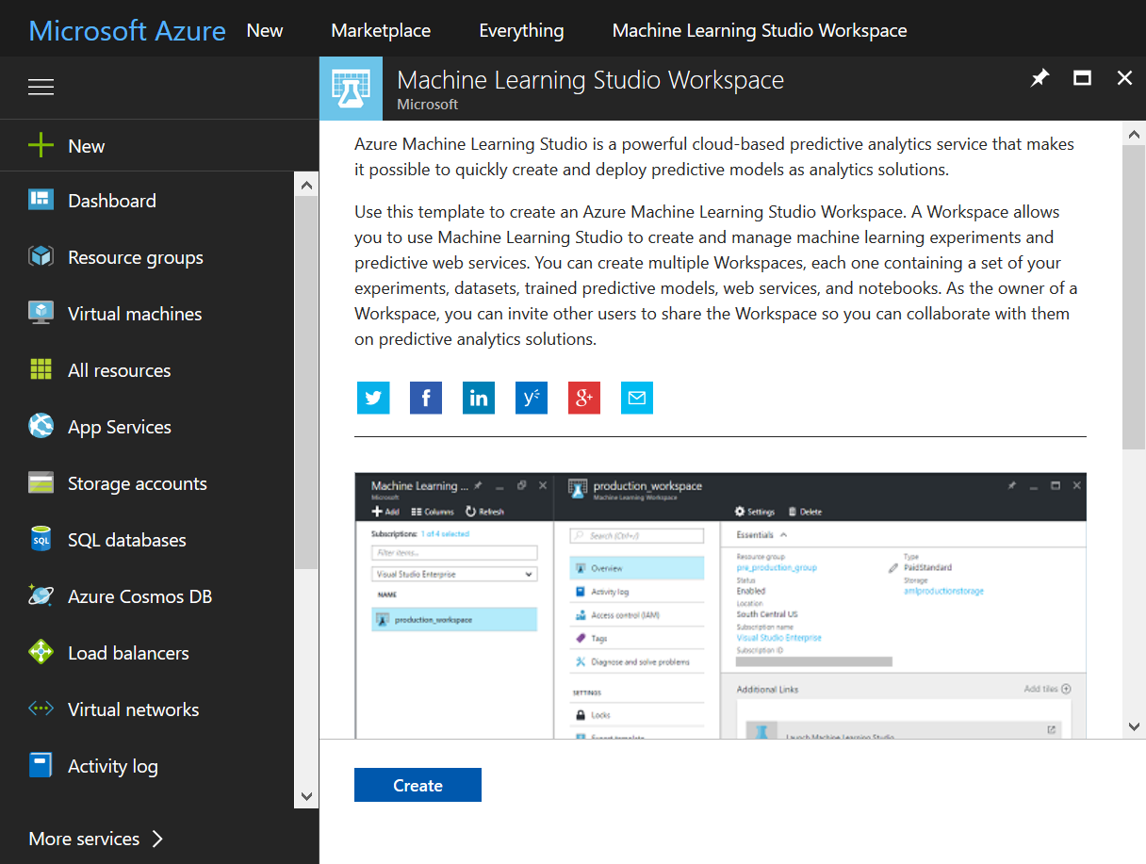

**Step 2**: Enter Workspace name, Resource Group Name, Location and Create New Storage Account for ML

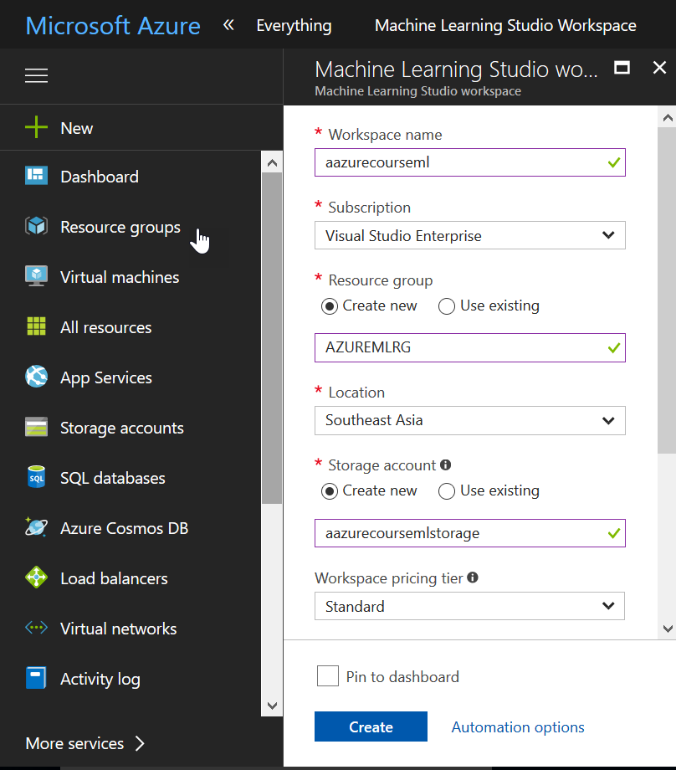

**Step 3:** After Deployment, Click on Launch Machine Learning Studio to launch ML studio

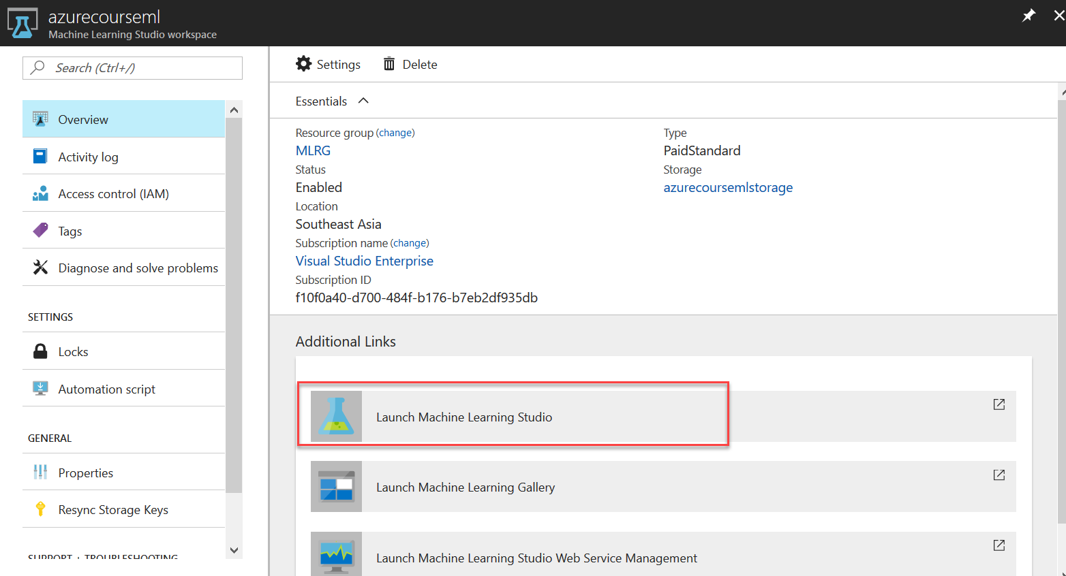

**Step 4:** Below is ML Studio in new browser tab, left side menu and bottom left NEW button to create new ML Experiment and to upload new Dataset.

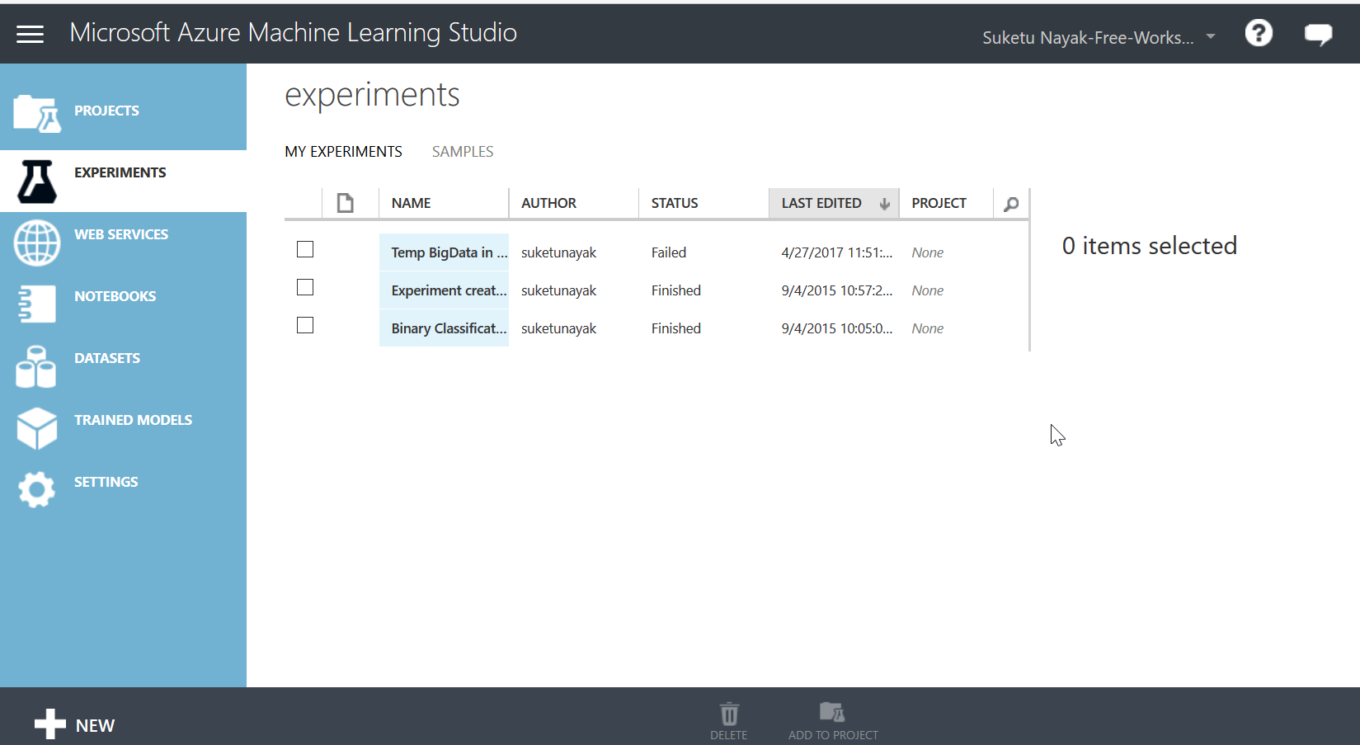

**Step 5:** Click on NEW Button to create new blank experiment

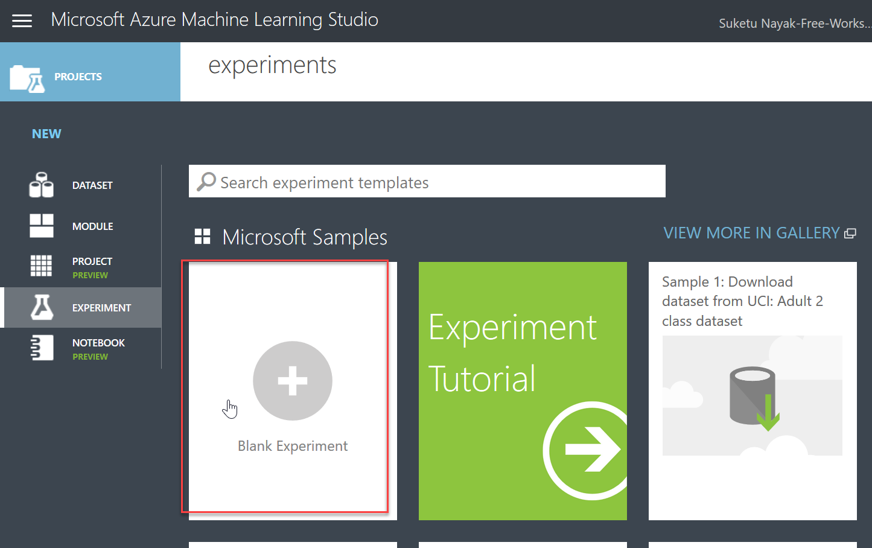

New Experiment Created you can rename it.

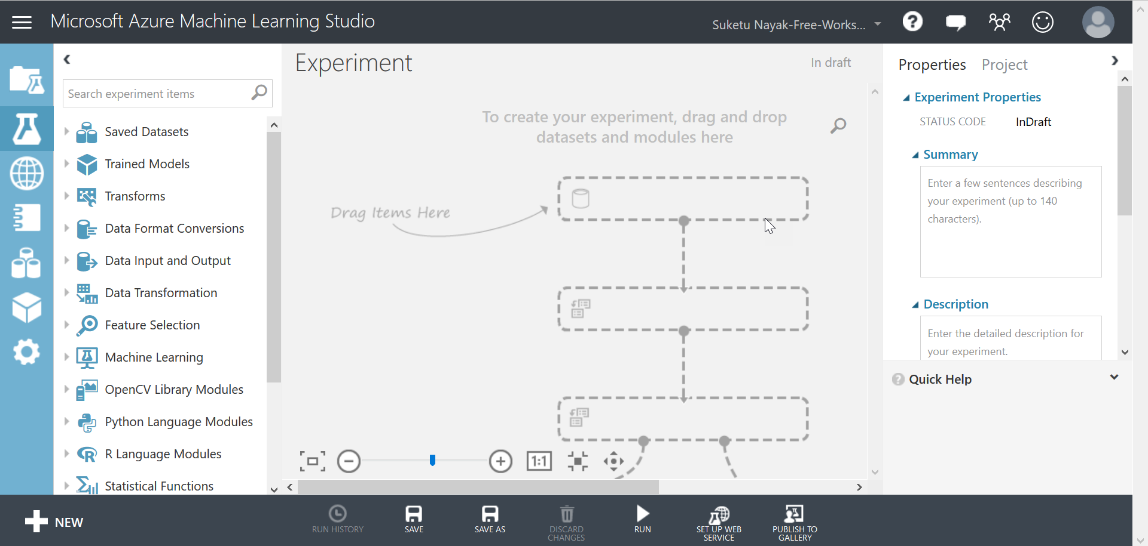

**Step 6:** We have Student Dataset in CSV File, like name, illness (In %), Attendance of last semester, SSC and HSC Result of that student, Father and Mothers Education (12 means HSC, 13 Means Graduate, 14 means Post Graduate), Stayed at Hostel, Study Hours (Per Day in Hrs), Disability if any, Schooling Medium and Last semester result (>=40 means Pass, <40 Means Fail)

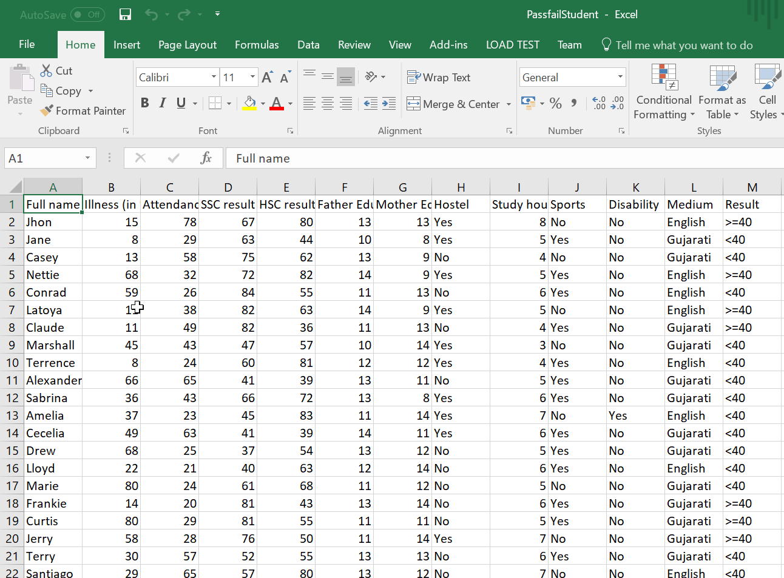

**Step 7:** Click on NEW Button and Click on **DataSet -> FROM Local File -> Select CSV** **and Upload**

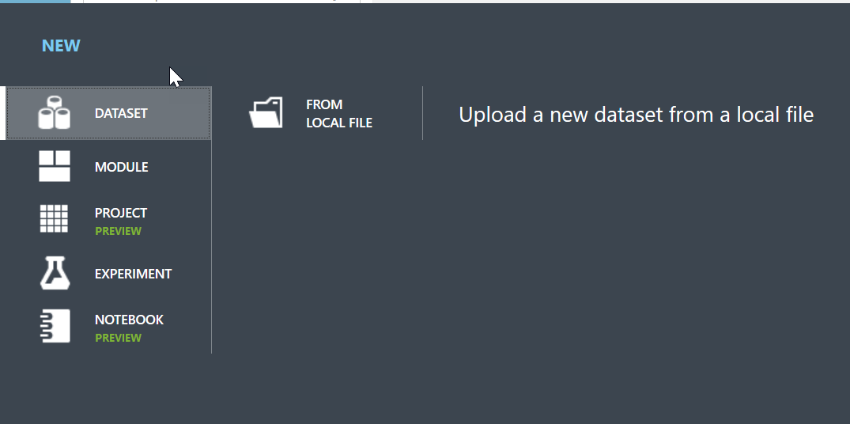

**Step 8:** Upload that CSV File on ML Studio -> Uploaded CSV File we can see in toolbar left side.

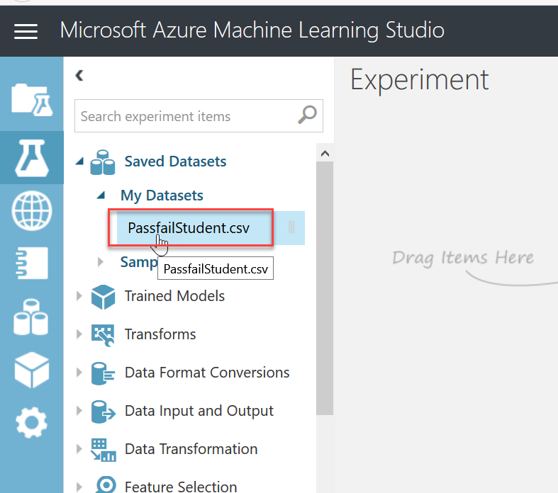

**Step 9:** Drag and Drop than Dataset File in Editor

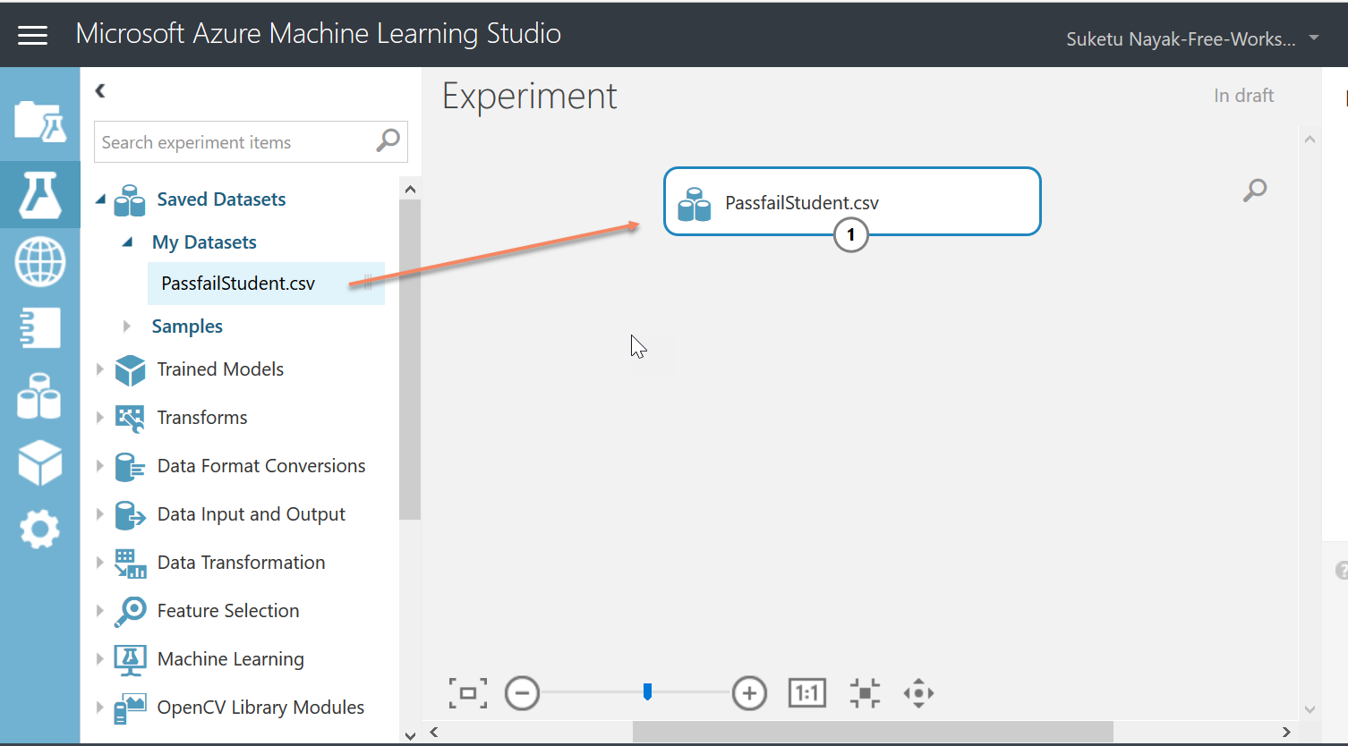

**Step 10:** Set Split Data Property = 0.7 -> We will use 70% Data for Training and 30% Data for Score Model to check How efficiently Train Model getting trained.

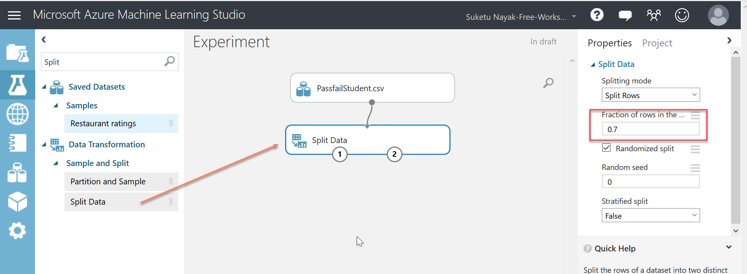

**Step 11:** Drag and Drop Train Model, Split Model and Evaluate Model like below snap.

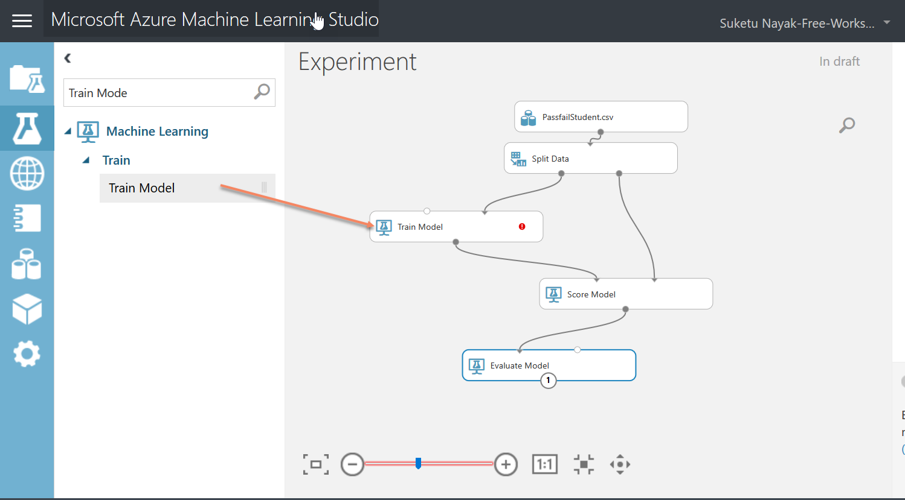

**Step 12:** Search for Classification Algorithm and drag and drop Two Class Decision Jungle Algo in Experiment

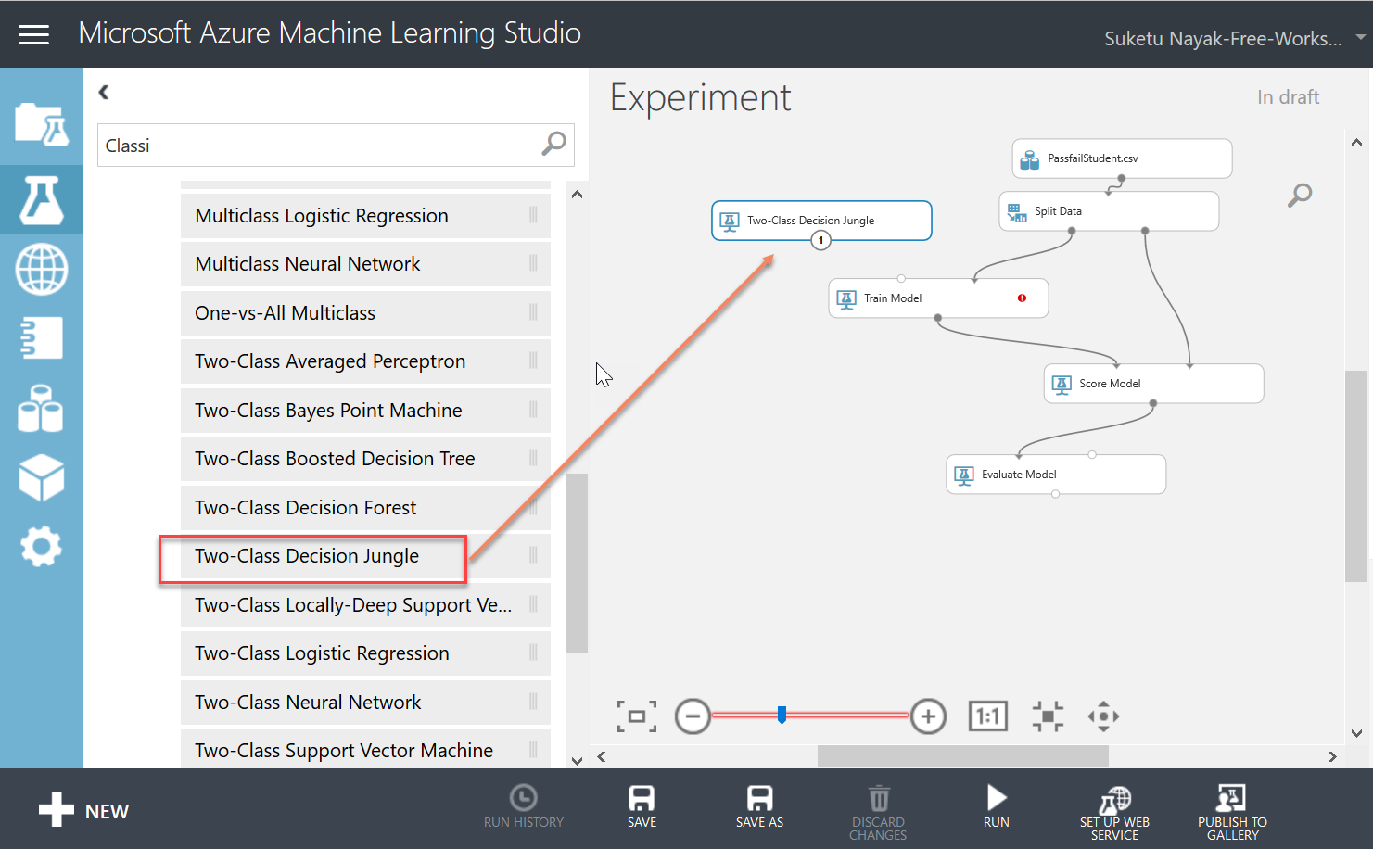

**Step 13:** Go to Property of Train Model and specify Train Model should learn to predict Result Field using Launch Column Selector.

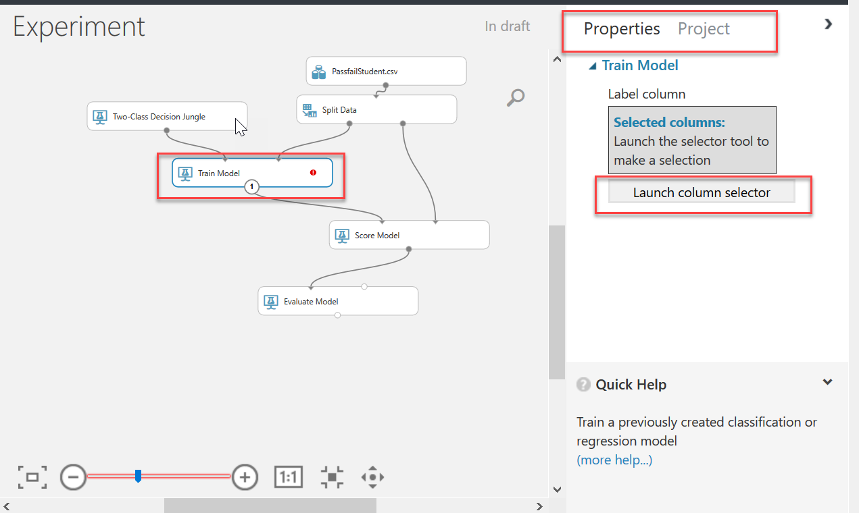

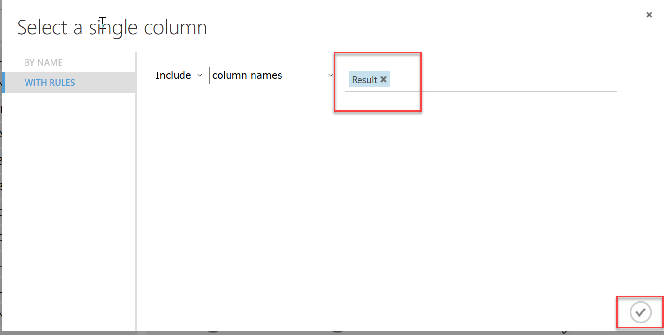

**Step 14:** Click on SAVE Button and then Click on RUN

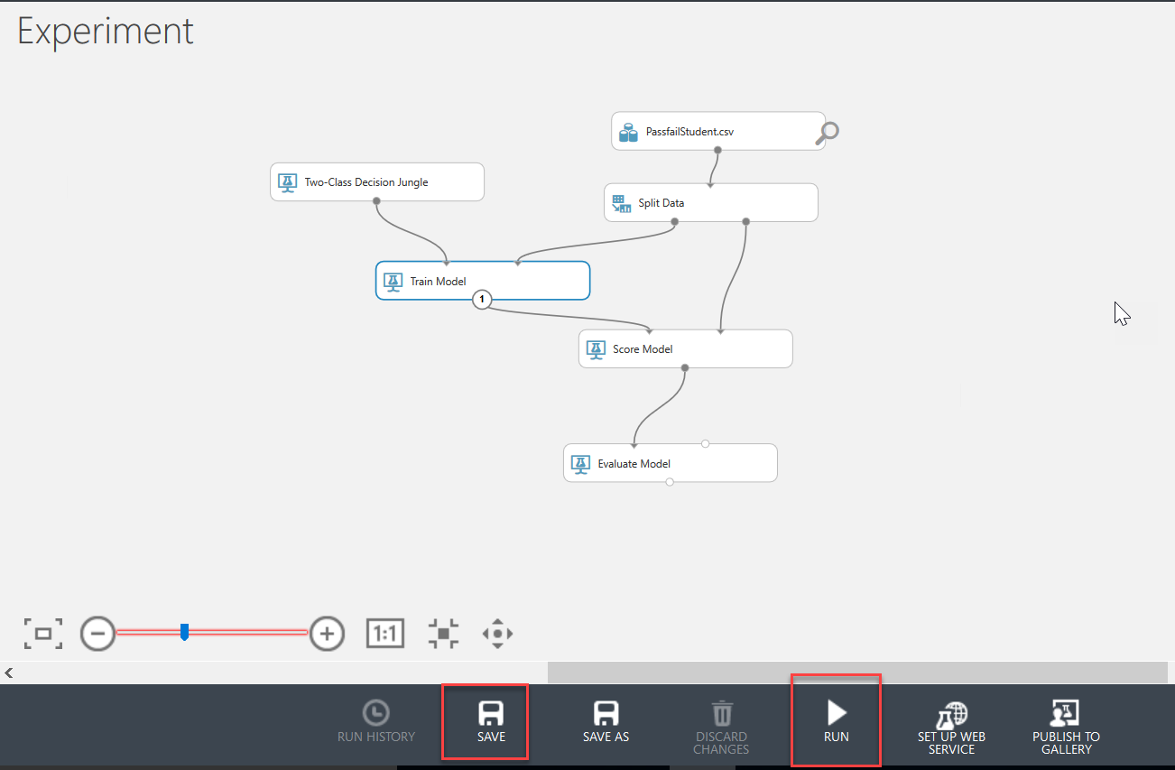

Green Right Tick means everything is OK.

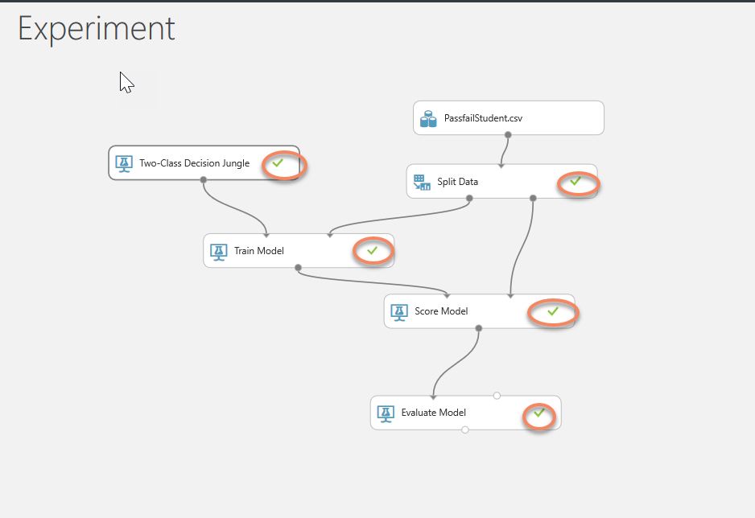

**Step 15:** Click on Set Up Web Service -> Predictive Web Service [Recommended]

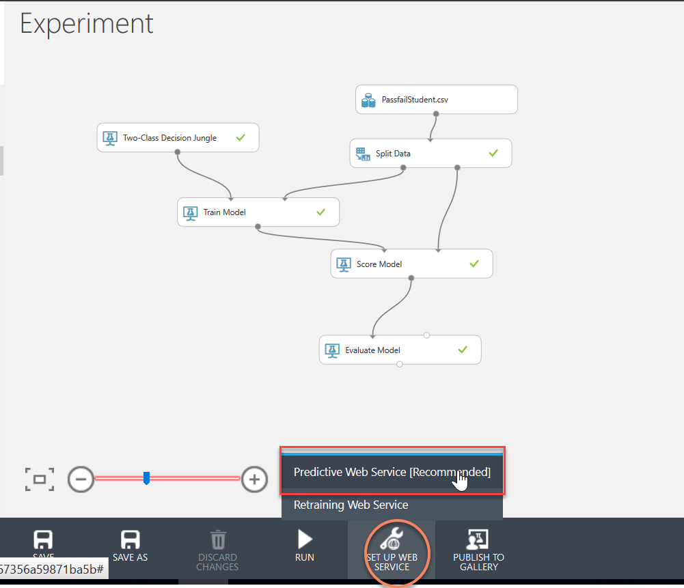

Now your training experiment will become predictive experiment.

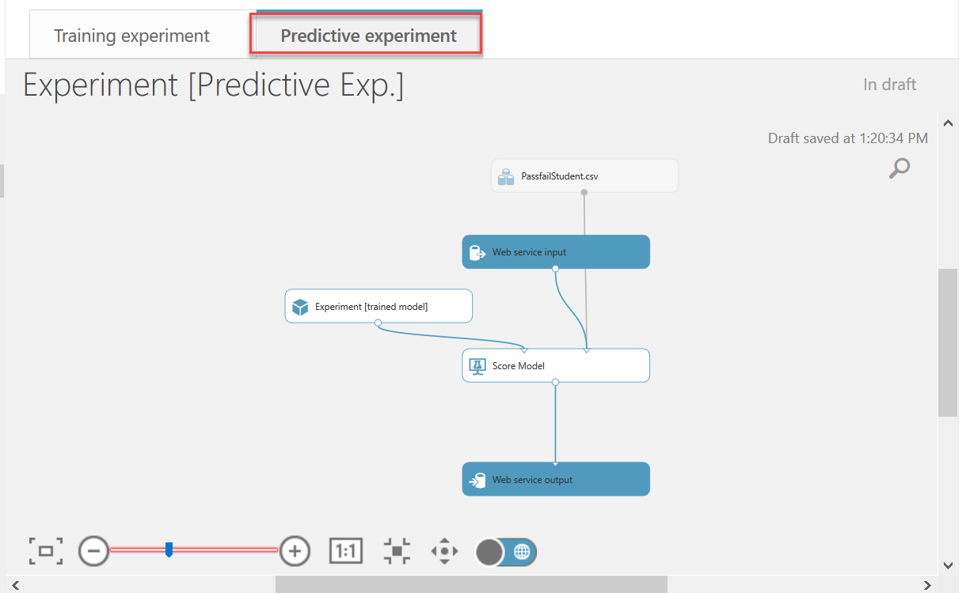

**Step 16:** Again, SAVE and RUN

In Training Experiment, we can right click on output of Score Model and Click on Visualize to check Score Results of Train Model See Below Snap

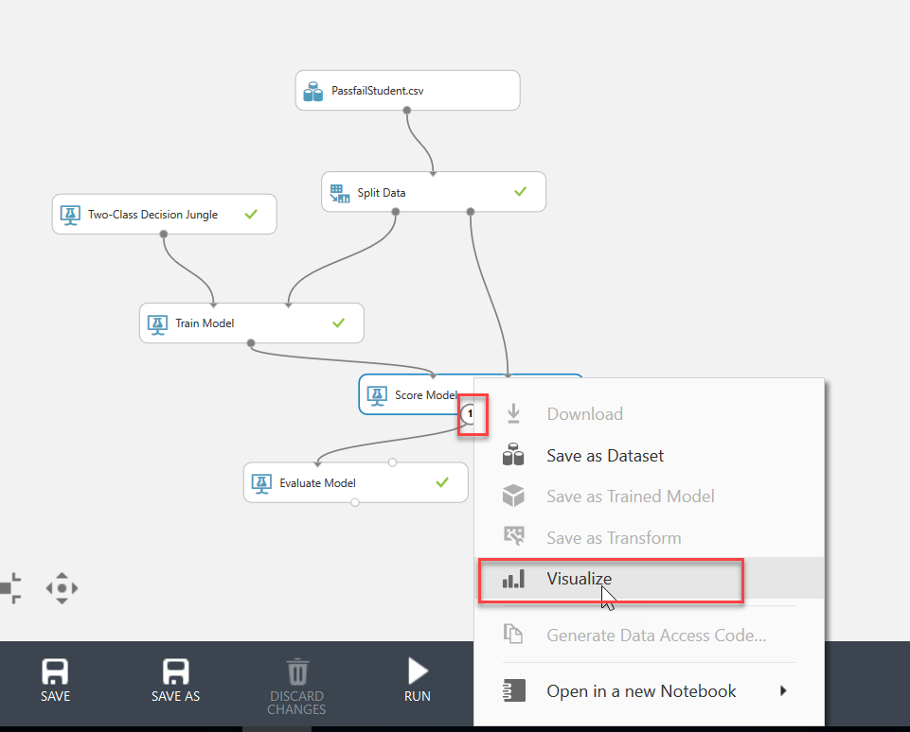

In below snap, Scored Labels are predicted result by Train Model and we can see its almost same as Result Field.

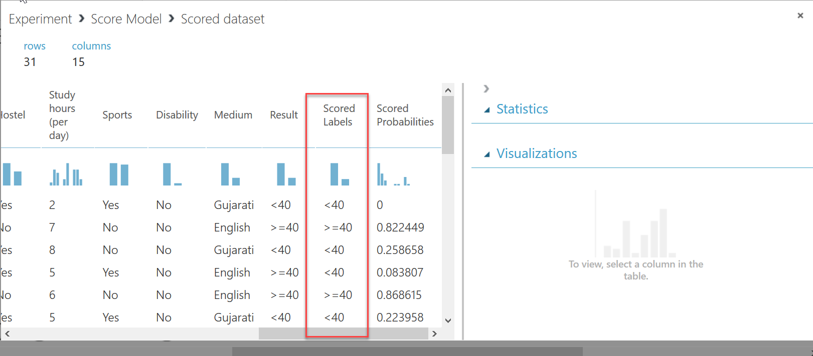

**Step 17:** Click on Visualize option of Menu of Evaluate Model (Right Click on Output Point of Evaluate Model to see Menu)

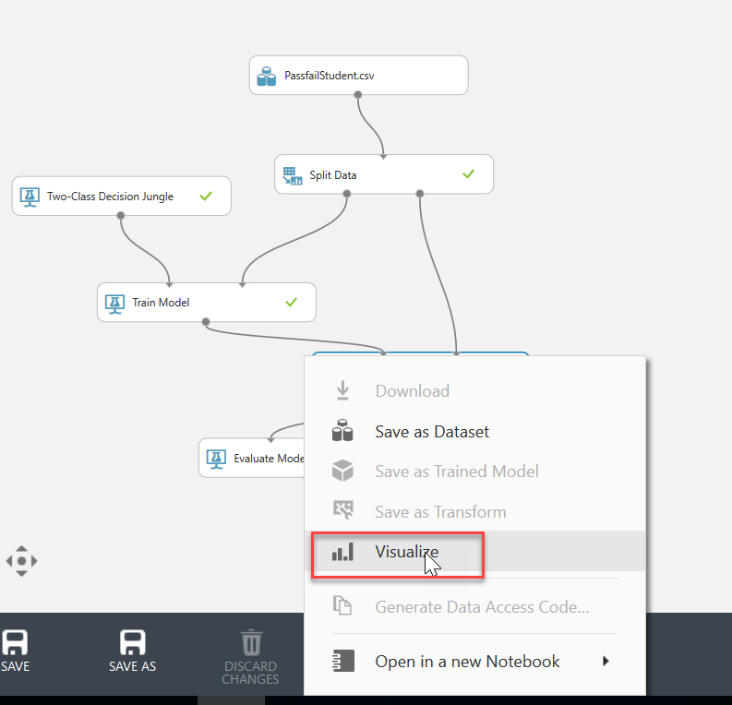

**Step 18:** In Evaluate Model you can see parameters of Algorithm, here in our case Accuracy of Algorithm is 71% that is good and acceptable

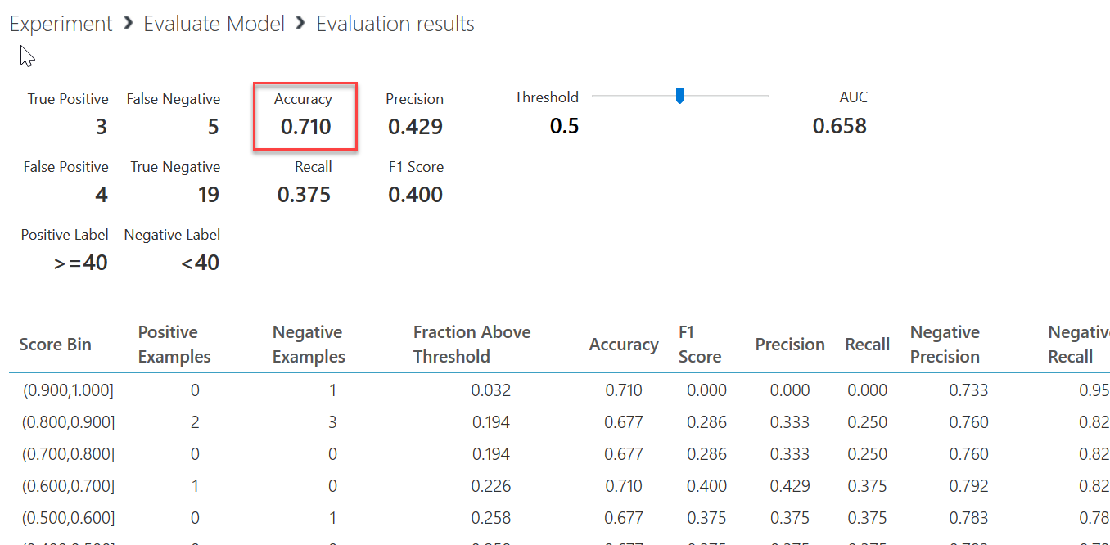

**Step 19:** Now Once Again Click on Predictive Algorithm and Run once again and convert it in to Web Service by clicking on Deploy We Service Button in bottom strip.

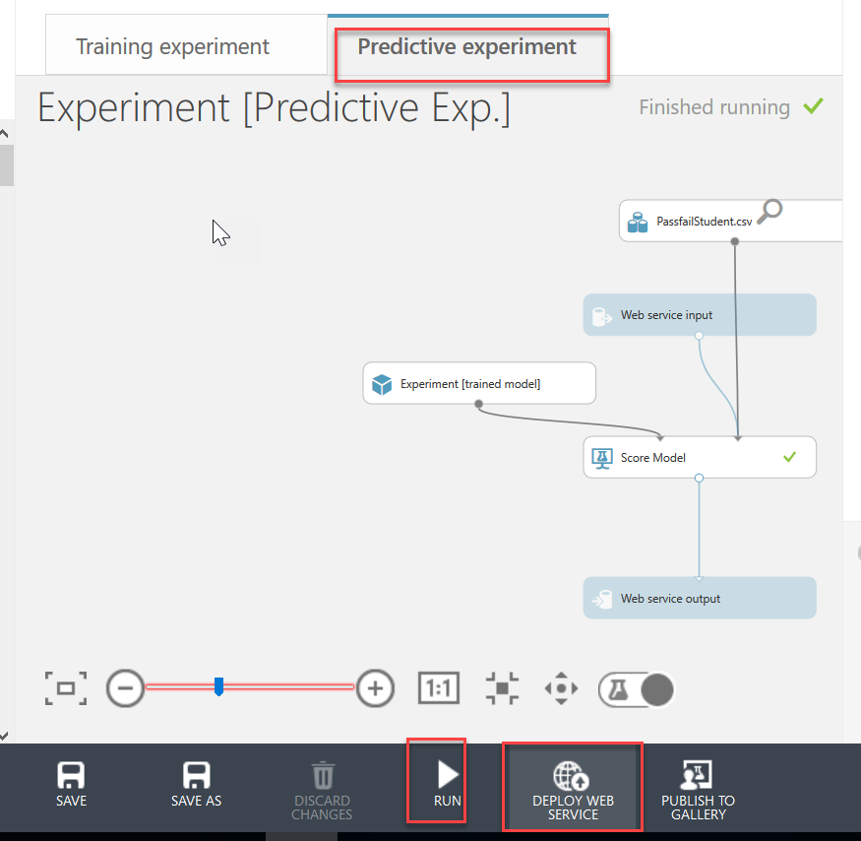

And Experiment converted in to Web Service.

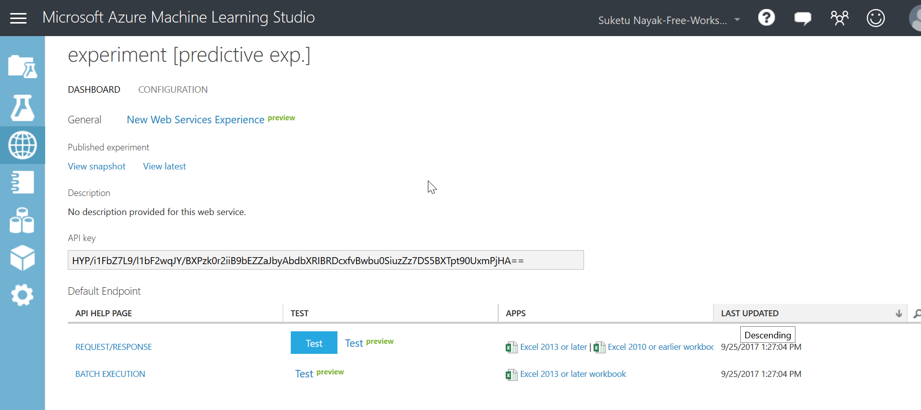

**Step 20:** We can click on Test Button and Test the prediction.

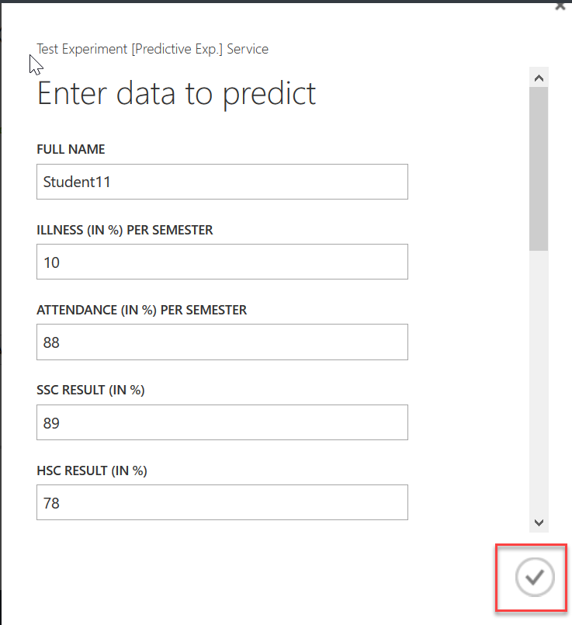

**Step 21:** See the Prediction in below snap -> **>=40**

